**Introduction**

Throughout history, man’s and woman’s figures in society have always been unbalanced at the expense of the latter. Women have always lacked privileges and rights, even just going out for a walk alone or to walk outside not keeping the head down was something inconceivable and unacceptable during some historical periods. As a result, women have been denied the chance to vote, to work, and to get higher education degrees until fairly recent times.

Following the Industrial Revolution and the WWI and WWII things started to change:

* They were gradually granted the right to vote;
* Colleges and Universities became accessible to them; and
* And gender discrimination in workplaces dropped significantly.

A study conducted by **Brigid Francis-Devine & Niamh Foley** and published on the parliament website**1** has registered the level of gender employment over the past 50 years:

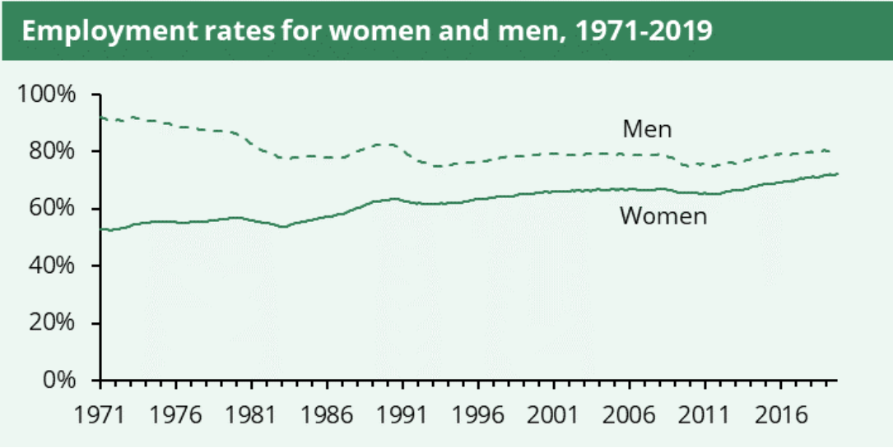

*The difference in women’s employment rate decreased from 40% to about 10%.*

There are probably two main implications in this change:

* The first one regards equal rights, in fact, having a job allows women to be considered at the same level as men on several fronts such as authority, independence, etc.
* The second one concerns employers who, of course, hire them.

**Should firms hire women?**

There are many benefits to hiring women:

* The firm has the possibility to choose from a wider pool of candidates;
* Researchers have observed that women have stronger skills reading non-verbal cues**2**;
* Diversity within the workplace can improve the overall morale; and
* Firm’s gain could boost as well.

About the last point, a study conducted at the MIT**3** recorded a marvellous increase of 41% on the revenue when men and women are even in quantity as compared to either all male or all female offices.

This growth sounds so good that the first thought would be to revisit the number of employees within the office to have them balance gender-wise, but there are 2 main issues:

* A 41% increase is very likely to pay off in the long run, but the cost of hiring new people to reach that equilibrium is immediate and could be very high;
* Also, imagine an office composed of 5 men and 5 women. 2 men leave the office.

What should the company do? Should they hire 2 men and make gender discrimination, or should candidates be considered solely on their background and capabilities, risking to compromise the balance?

This would probably be a very tough choice that the firm would address to the Human Resource Department, and of course this is not the only issue that the department would come across. Think about hiring women, it is not enough to advertise vacancies in order to have them applying, in fact, hiring women is like a vicious circle, the more you have on board the more will candidate for your firm, but an initial lack would discourage new female candidatures.

So, how do you encourage them to join your firm? This is another challenge for Human Resource. The answer would probably be to improve the reputation of the company to make it more attractive to women and to promote diversity in the workplace – as they seem very sensitive about the matter – but also rebranding the employee value proposition so that it better fits female employees should be taken into consideration.

Another challenge regarding women are interviews, and the selection process in general, as interviewers are often biased, and their choices may be influenced by physical appearances. HR can do a lot about this, for example providing interviewers with standardised questions, structuring the selection process, and clearly defining the criteria the company is looking for in the candidate. The first two points are fundamental for reducing bias as much as possible, whereas the last one has other obvious implications and can protect the firm from legal actions in the case the candidate believes that she has been discarded due to gender discrimination.

To sum up, human resources management has to deal with a multitude of issues in order to attract, engage, and retain female employees; however, women can be an incredibly valuable resource for the company and, when HR succeeds in these tasks to have them join the firm, the payoffs could be well worth the effort.